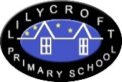
Starting in Reception in September 2021
Information for New Starters

Welcome to Lilycroft Primary School.

We are very pleased that your child has a place at our school for September 2021.

We will be in touch with you in June to invite you to a meeting in school.
At this meeting, we will give you lots of information about starting school and you will meet your child’s class teacher.
There will be opportunities for you to ask any questions.
(Meeting will go ahead provided Covid restrictions allow.)

We are looking forward to meeting you.

